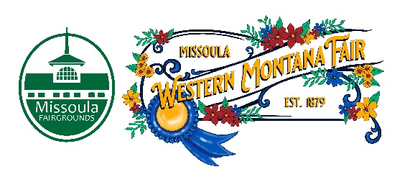

Missoula County Fair Event Committee
Thursday, March 9th, 2023, at 10:00 a.m.
Fair Office, Building #12
Missoula County Fairgrounds
1101 South Avenue West, Missoula, MT 59801

Committee Members

- Jim Sadler – Chair
- Dave Bell - Vice-Chair
- Sarah Knobel
- Brooke Martin
- Campbell Barrett
- Tonya Robert
- Jane Kelly
Agenda

- Meeting commencement
- Rollcall & introductions
- Approval of agenda
- Public comment on items not on the agenda
- Action Items
- Approval of minutes from February 9, 2023
- Discussion Items
- 2023 Western Montana Fair
  - Legends Night Nominations Rubric/Application Review
  - Entertainment Update
  - Vendors
  - Premium Book/ShoWorks
  - Judges
  - Tickets on sale
  - Pre-Fair Workshops
  - Rock the Red news
- 4-H update
- Development update
  - Russell St. sidewalk upgrades
- Adjournment – Next meeting Thursday, April 13th, 2023, 10:00 a.m., at Missoula County Fairgrounds, Fair Office, Building #12, 1101 South Avenue W, Missoula, MT 59801.

