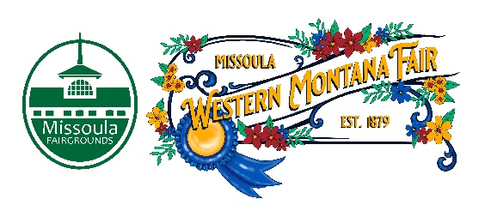

Missoula County Fair Event Committee
Thursday, October 12th, 2023, at 10:00 a.m.
Fair Office, Building #12
Missoula County Fairgrounds
1101 South Avenue West, Missoula, MT 59801

Committee Members

- Jim Sadler – Chair
- Dave Bell - Vice-Chair
- Sarah Knobel
- Brooke Martin
- Tonya Robert
- Jane Kelly
- Hailey Jo Bergstrom

Meeting Minutes

- Meeting commencement
  - Chair Jim Sadler called the meeting to order at 10:00 a.m. Jim Sadler, Jane Kelly, Dave Bell, Brooke Martin, Allison Wilson, Jacey Grange & Tenzin Lhaze were present.
- Rollcall & Introductions
- Approval of Agenda
  - Agenda has been approved for October.
- Public comment on items not on the agenda
  - None
- Action Items
- Approval of minutes with one change that Sarah Knobel was present in September’s meeting.
- Discussion Items
- 6- day fair
  - 6-day Fair has been approved. Tuesday will be a large-scale musical act followed by regular events. Brooke adds that a 6-day Fair will be a problem for 4-H because of scheduling and that we will need to have a livestock management plan in place. Allison adds that the Livestock committee has been presented 2 different schedule proposals for a 6-day Fair and that they are currently in discussion. Jim adds that a 6-day Fair will also need schedule consideration for floriculture & agriculture.
- Food Vendor Feedback
  - Jacey has had 15 meetings so far with food vendors. Most of it was positive feedback. Food vendors seem receptive to a 6-day Fair. Their main concern would be staffing for 6 days. Brooke suggested a return to opt-in food vendor contest. Food vendors would need to bring their food in on a certain day and time to participate.
- Committee Idea
  - Different committee ideas were suggested to the Fair Event Committee. Fair food contest committee will be continued. Other ideas were tabled for now.
- RFP Assignments
  - This is a continued topic from last month. There will be several RFP assignments. Fair Event Committee members are welcome to sign up for an RFP. Brooke and Jim will be helping with the Bar RFP. Dave Bell and Jane Kelly will be helping with the Trash/Recycling/Compost RFP. Fair staff will be in touch with Fair Event Committee members.
- 4-H Update
  - 4-H is currently having their award nominations right now.
- Development Update
  - Grandstand demolition
    - Grandstands demolition will be happening on November 2.
  - Ribbon Cutting Ceremony
    - Ribbon cutting ceremony will be happening at a certain point.
- Adjournment
  - Meeting adjourned at 11:00 a.m. Next meeting Thursday, December 14th, 2023, 10:00 a.m., at Missoula County Fairgrounds, Fair Office, Building #12, 1101 South Avenue W, Missoula, MT 59801.

