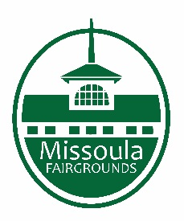
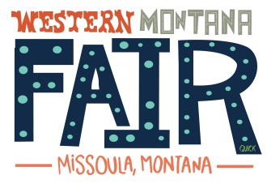

Missoula County Fair Event Committee
Thursday, January 12th, 2023, at 10 a.m.

Join on your computer or mobile app
Click here to join the meeting
Join with a video conferencing device
623215837@t.plcm.vc
Video Conference ID: 117 820 816 5
Alternate VTC instructions
Or call in (audio only)
+1 406-272-4824,,320041674# United States, Billings
Phone Conference ID: 320 041 674#

Committee Members

- Jim Sadler – Chair
- Dave Bell - Vice-Chair
- Sarah Knobel
- Brooke Martin
- Campbell Barrett
- Tonya Robert
- Jane Kelly
Agenda

- Meeting commencement
- Rollcall & introductions
- Approval of agenda
- Public comment on items not on the agenda
- Action Items
- Approval of minutes from December 2022
- Discussion Items
- Staff Introductions
- 2023 Fair
  - Entertainment Updates
  - Vendor Applications
  - Volunteer Updates
  - PRCA Rodeo Applications
  - Pageant Update
- 2024 Fair
  - Theme
- Winter Fair
- 4-H update
- Development update
  - Software Discussion (Ungerboeck and PlacerAI)

- Adjournment – Next meeting Thursday, February 9^{h}, 2023, 10 a.m. at the Missoula County Fairgrounds Office, Building #12, 1101 South Ave. West.

