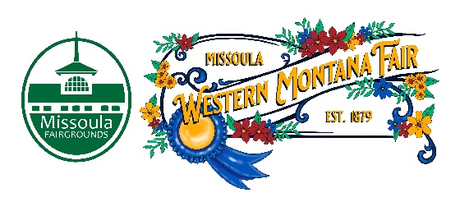C:\Users\awilson\OneDrive - Missoula County\Desktop\Public Comment April 12 23.pdf

Missoula County Fair Event Committee
Thursday, May 11 , 2023, at 10:00 a.m.
Fair Office, Building #12
Missoula County Fairgrounds
1101 South Avenue West, Missoula, MT 59801

Committee Members

- Jim Sadler – Chair
- Dave Bell - Vice-Chair
- Sarah Knobel
- Brooke Martin
- Campbell Barrett
- Tonya Robert
- Jane Kelly
- Hailey Bergstrom
Agenda

- Meeting commencement
- Rollcall & introductions
  - New member- Hailey Bergstrom
- Approval of agenda
- Public comment on items not on the agenda
- Action Items
  - Approval of minutes from April 13, 2023
- Discussion Items
  - April meeting public comment
- 2023 Western Montana Fair
  - RMAF Spring Tour Report
  - Pageant update
  - Entertainment Schedule
  - Food map
  - Fair water bottles ordered.
- 4-H update
- Development update
  - 2024 Western Montana Fair “Rocket’s Red Glare” sub-slogan
- Adjournment – Next meeting Thursday, June 8th, 2023, 10:00 a.m., at Missoula County Fairgrounds, Fair Office, Building #12, 1101 South Avenue W, Missoula, MT 59801.

