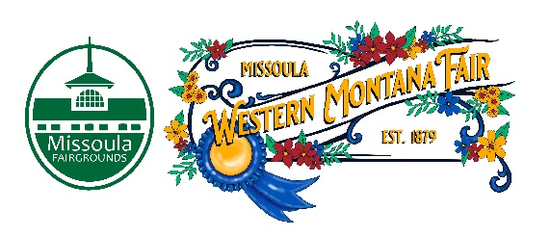

Missoula County Fair Event Committee
Thursday, April 13th, 2023, at 10:00 a.m.
Fair Office, Building #12
Missoula County Fairgrounds
1101 South Avenue West, Missoula, MT 59801

Committee Members

- Jim Sadler – Chair
- Dave Bell - Vice-Chair
- Sarah Knobel
- Brooke Martin
- Campbell Barrett
- Tonya Robert
- Jane Kelly
Agenda

- Meeting commencement
- Rollcall & introductions
  - Alternate board member update.
- Approval of agenda
- Public comment on items not on the agenda
- Action Items
- Approval of minutes from March 9, 2023
- Discussion Items
- 2023 Western Montana Fair
  - Legends Night Nominations
  - JRPC partnership
  - ADA Carnival
  - MPL Partnership
  - Vendors- food, bingo, west lawn
  - Fair Activities
  - Camping
  - Pen Portraits
- 2024 Fair update
  - Rodeo RFP committee
- 4-H update
- Development update
- Adjournment – Next meeting Thursday, May 11th, 2023, 10:00 a.m., at Missoula County Fairgrounds, Fair Office, Building #12, 1101 South Avenue W, Missoula, MT 59801.

